**Prerequisite :**

**Joins:**

The SQL **Joins** clause is used to combine records from two or more tables in a database. A JOIN is a means for combining fields from two tables by using values common to each.

**Types of Join :-**

**1. Cross Join :-**

The **CARTESIAN JOIN** or **CROSS JOIN** returns the Cartesian product of the sets of records from the two or more joined tables. Thus, it equates to an inner join where the join-condition always evaluates to True or where the join-condition is absent from the statement.

## Example:

Consider the following two tables

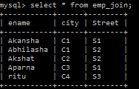 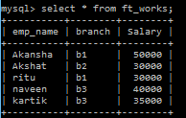

Now, let us join these two tables using CROSS JOIN

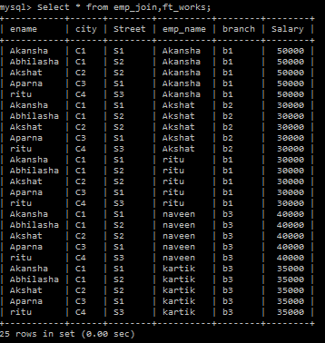

**2. Natural Join:-**

A **NATURAL JOIN** is a **JOIN** operation that creates an implicit **join** clause for you based on the common columns in the two tables being joined. Common columns are columns that have the same name in both tables.

## Example:

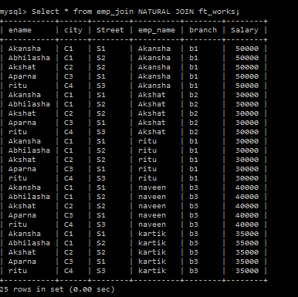

**3. Inner Join:-**

The INNER JOIN keyword selects all rows from both tables as long as there is a match between the columns in both tables.

## Example:

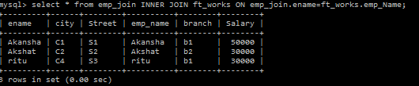

**4. Outer Join:-**

**A - Left Outer Join-**

The LEFT JOIN keyword returns all rows from the left table (table1), with the matching rows in the right table (table2). The result is NULL in the right side when there is no match.

## Example:

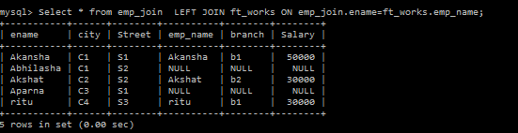

**B - Right Outer Join-**

he RIGHT JOIN keyword returns all rows from the right table (table2), with the matching rows in the left table (table1). The result is NULL in the left side when there is no match.

## Example:

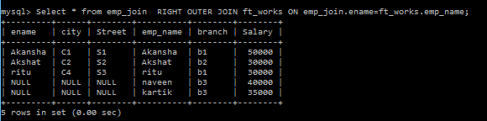

**C - Full Outer Join-**

The FULL OUTER JOIN keyword returns all rows from the left table (table1) and from the right table (table2).

The FULL OUTER JOIN keyword combines the result of both LEFT and RIGHT joins.

## Example:

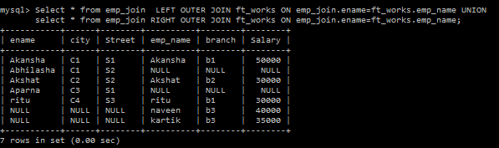

**Prerequisite :**

A Subquery or Inner query or Nested query is a query within another SQL query and embedded within the WHERE clause.A subquery is used to return data that will be used in the main query as a condition to further restrict the data to be retrieved.Subqueries can be used with the SELECT, INSERT, UPDATE, and DELETE statements along with the operators like =, <, >, >=, <=, IN, BETWEEN etc.

There are a few rules that subqueries must follow:

* Subqueries must be enclosed within parentheses.
* A subquery can have only one column in the SELECT clause, unless multiple columns are in the main query for the subquery to compare its selected columns.
* An ORDER BY cannot be used in a subquery, although the main query can use an ORDER BY. The GROUP BY can be used to perform the same function as the ORDER BY in a subquery.
* Subqueries that return more than one row can only be used with multiple value operators, such as the IN operator.
* A subquery cannot be immediately enclosed in a set function.
* The BETWEEN operator cannot be used with a subquery; however, the BETWEEN operator can be used within the subquery.

Consider the following two tables

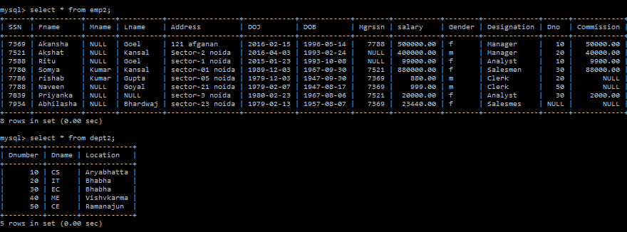

Q- Display name of department where there is atleast one employee.

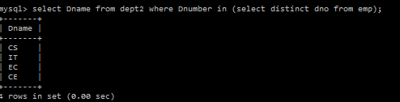

Q- Display the fname,lname,dno,salary of all employees who have same salary & the designation of all employees who work for manager 7788;

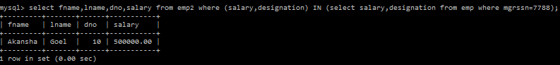

Q- Display the department name of the emp whose SSN=7788.

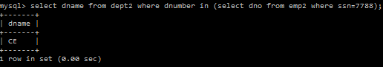

Q- Display lname ,fname,Salary of all employee who work in same department as the employee whose last name is ‘Gupta’

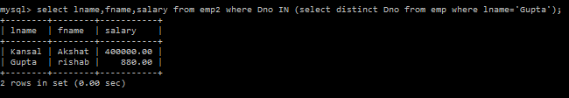

Q- Display the Fname,Lname& Designation of any employee employed by an existing department.

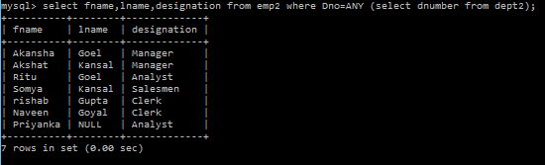

Q- Find the employee with lowest salary.

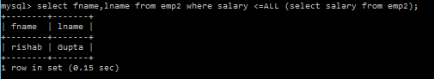

Q- Display the name of all department with no employee.



**Prerequisite :**

An operator is a reserved word or a character used primarily in an SQL statement's WHERE clause to perform operation(s), such as comparisons and arithmetic operations.

Various types of logical operator:-

|  |  |
| --- | --- |
| **Operator** | **Description** |
| ALL | The ALL operator is used to compare a value to all values in another value set. |
| AND | The AND operator allows the existence of multiple conditions in an SQL statement's WHERE clause. |
| ANY | The ANY operator is used to compare a value to any applicable value in the list according to the condition. |
| BETWEEN | The BETWEEN operator is used to search for values that are within a set of values, given the minimum value and the maximum value. |
| EXISTS | The EXISTS operator is used to search for the presence of a row in a specified table that meets certain criteria. |
| IN | The IN operator is used to compare a value to a list of literal values that have been specified. |
| LIKE | The LIKE operator is used to compare a value to similar values using wildcard operators. |
| NOT | The NOT operator reverses the meaning of the logical operator with which it is used. Eg: NOT EXISTS, NOT BETWEEN, NOT IN, etc. **This is a negate operator.** |
| OR | The OR operator is used to combine multiple conditions in an SQL statement's WHERE clause. |
| IS NULL | The NULL operator is used to compare a value with a NULL value. |
| UNIQUE | The UNIQUE operator searches every row of a specified table for uniqueness (no duplicates). |